In order to view and download the necessary code files, click on the given link below and download the folder in .zip format.

[**https://drive.google.com/drive/folders/1Pes10DAR00ItiQxUSOlbbEx72i3-z304?usp=sharing**](https://drive.google.com/drive/folders/1Pes10DAR00ItiQxUSOlbbEx72i3-z304?usp=sharing)

The reason behind giving the codes of the project developed in .zip format and not in pdf format is mainly due to the fact that there are a lot of code files that are necessary to run the complete software.

Following are the key frameworks that are needed to be downloaded and installed in order to run the project:

1. **Selenium: conda install -c conda-forge selenium**

The portable framework selenium is used in the project for testing purposed of the web application. This open-source tool automates the Facebook user interface . Selenium Python is used in the project from logging in the facebook account and extracting the statuses of user. With the help of selenium web driver the process of automation becomes easy. It is the web framework which allows us to execute cross-browser tests. The latest web driver drives a browser natively, as a user would, either locally or on a remote machine using the Selenium server. It refers to both the language bindings and the implementations of the individual browser controlling code.

1. **Scikit-learn: conda install -c anaconda scikit-learn**

The machine learning library in Python Scikit-learn contains a lot of efficient tools for machine learning and statistical modeling including classification, regression, clustering and dimensionality reduction. It features various algorithms like support vector machine, random forests, and k-neighbours, and it also supports Python numerical and scientific libraries like NumPy and SciPy. In our project Scikit-learn is used in training the Machine Learning model based on both regression as well as classification values of the data.

1. **Chrome driver: https://chromedriver.chromium.org/downloads**

(download driver compatible to your chrome and save it on the location of fb_webscrapper.ipynb)

This is the open source tool for automated testing of webapps across many browsers. For the facebook automation with the help of selenium on chrome browser, we have used Chrome web driver which provides capabilities for navigating to web pages, user input, JavaScript execution, and more. In order to control a Chrome browser running on the local machine chrome driver is used.

1. **MongoDb: https://www.mongodb.com/try/download/community (download 4.4.6 zip file, unzip it and install)**

The cross platform document oriented No-SQL database is used in our project in order to store all the information such as statuses, profile picture, etc of the user in the database and then use it in further process to predict personality. In it used to store large amount of data which usually cannot be stored in the SQL relational databases.

1. **Node.js: https://nodejs.org/en/**

(download 14.17.0 LTS and install)

It is an non-proprietary software server environment which allows you to run JavaScript on the server.

A simplified model of event-driven programming which uses callbacks to signal the completion of a task

is used to create extensible servers without using threading.

Reactjs code can be executed directly in the Nodejs environment.

The React DOM has elements precisely designed to work with Nodejs that

reduce lines of code, which makes server-side rendering easy.

1. **Flask: conda install -c anaconda flask**

Flask is an API of Python that allows us to build up web-applications.

It is a micro web framework used to connect backend and frontend.

It is mostly used because it has less base code to implement a simple web-Application.

1. **Flask-cors: conda install -c anaconda flask-cors**

It is a Flask extension for handling Cross Origin Resource Sharing.

This extension by default enables CORS support on all routes

using which information from port 5000 which displays data of mongodb can be displayed on port 3000.

After the installation, follow the below mentioned step for running the project:

1. Save all the **.py** and **.ipynb** files in trial folder.

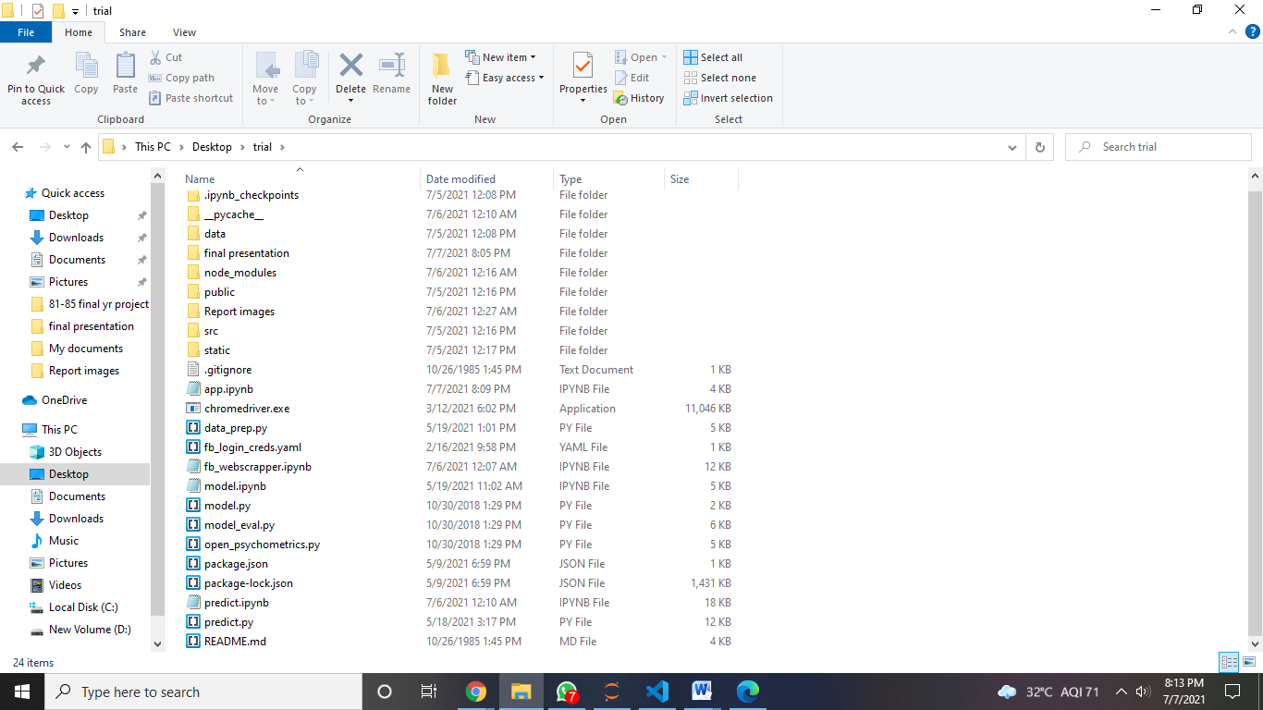

1. Execute **model.ipynb** given in the drive location.

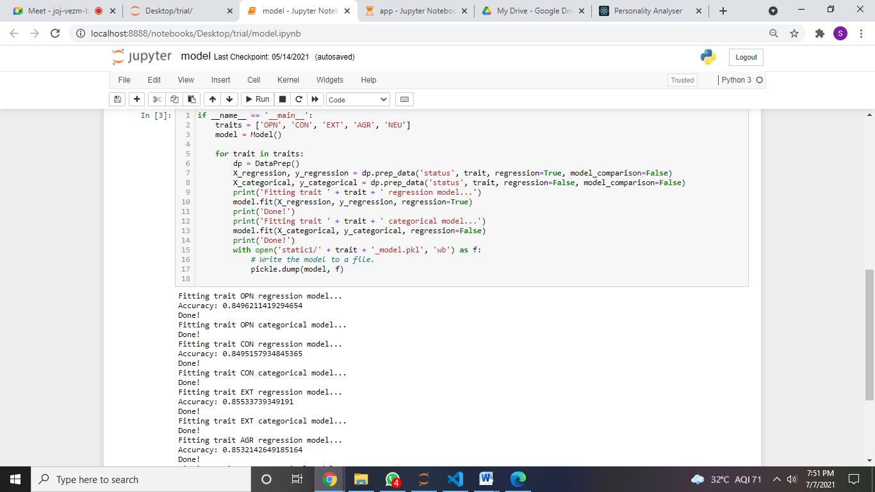

1. Also download the model.ipynb in .py file and save it in a folder.
2. Save the login credentials of the Facebook to access in the file **fb_login_creds.yaml**.

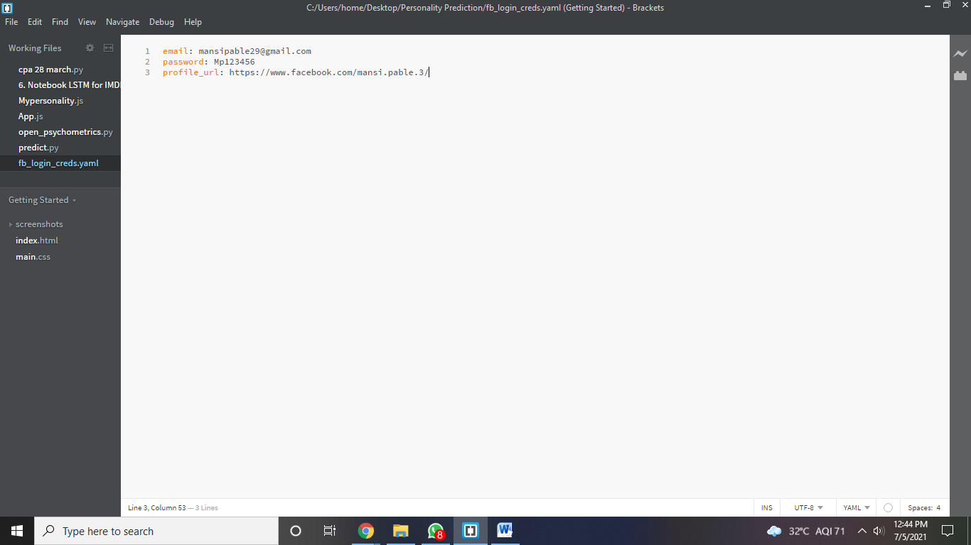

1. Execute **fb_webscrapper.ipynb** given in the drive location.

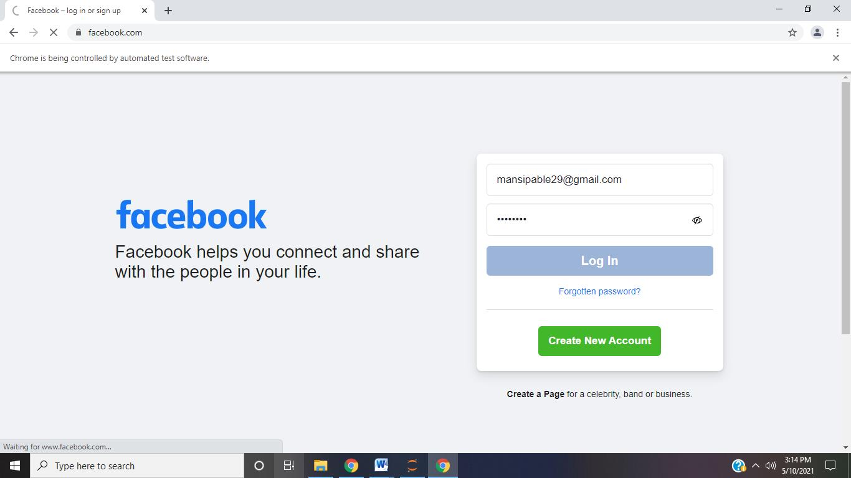

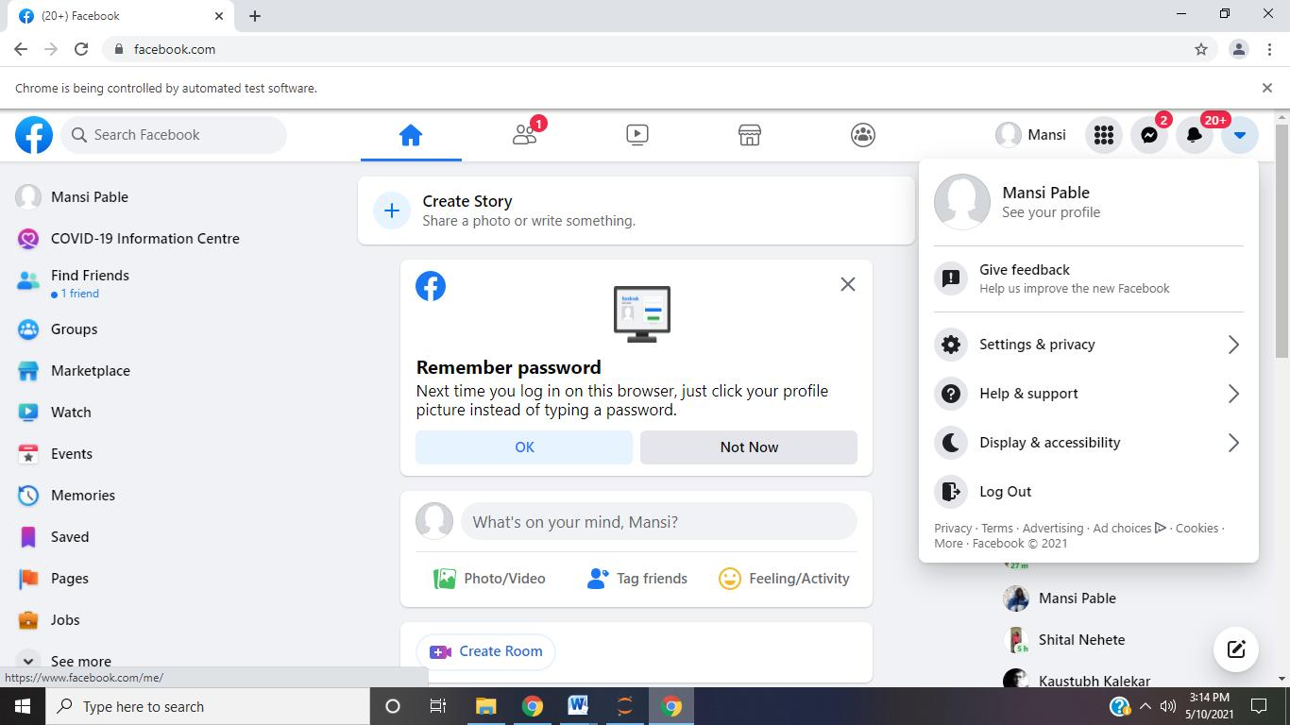

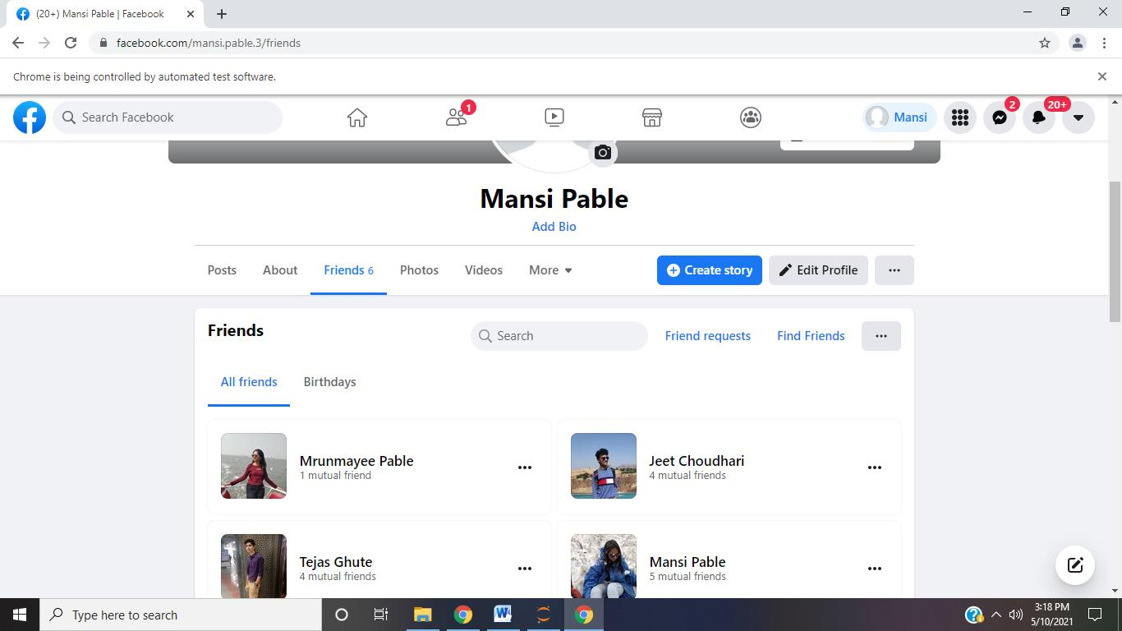

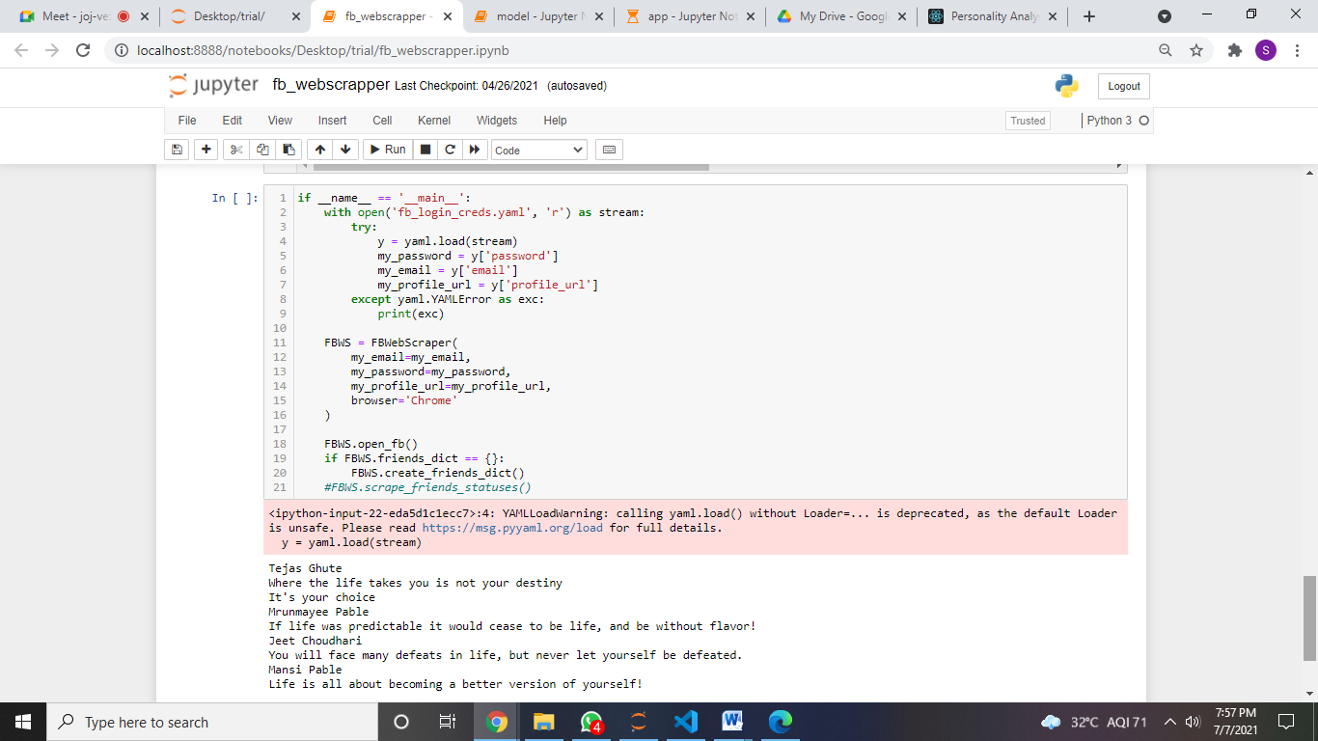

1. Execute **predict.ipynb**  given in the drive location.

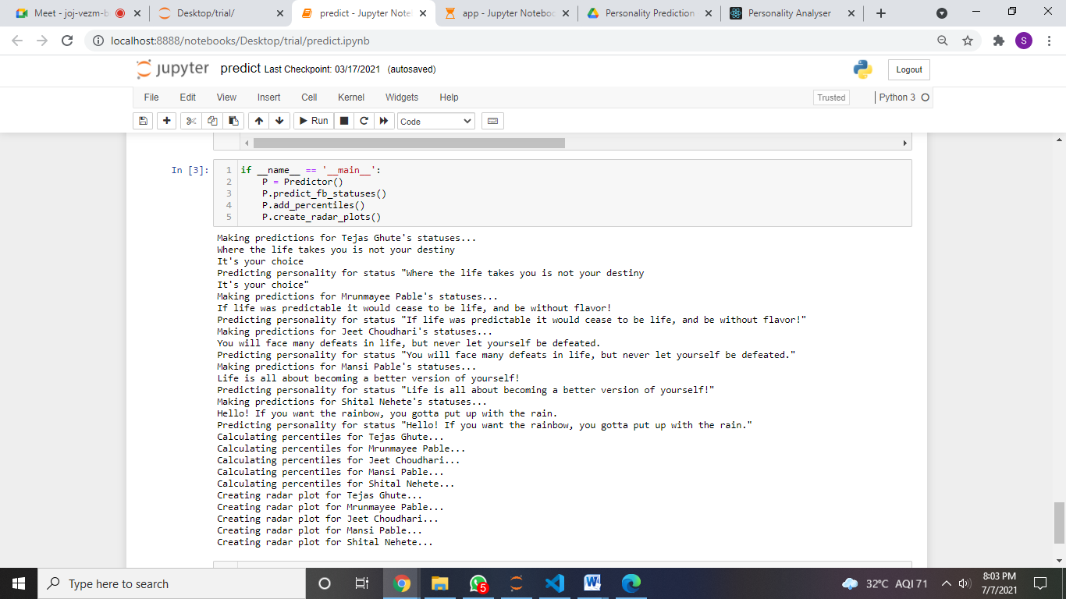

1. Go to C:, Program Files, Mongo DB, Server, 4.4, bin, mingo.exe. and type commands **use pprediction** and **db.statuses.find()**.

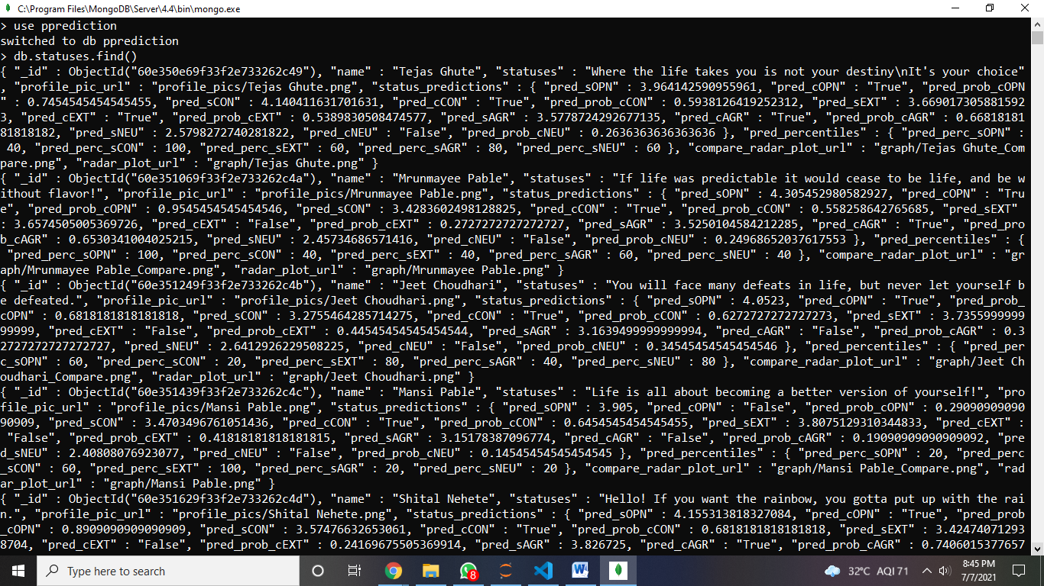

1. Execute **app.ipynb** given in the drive location.

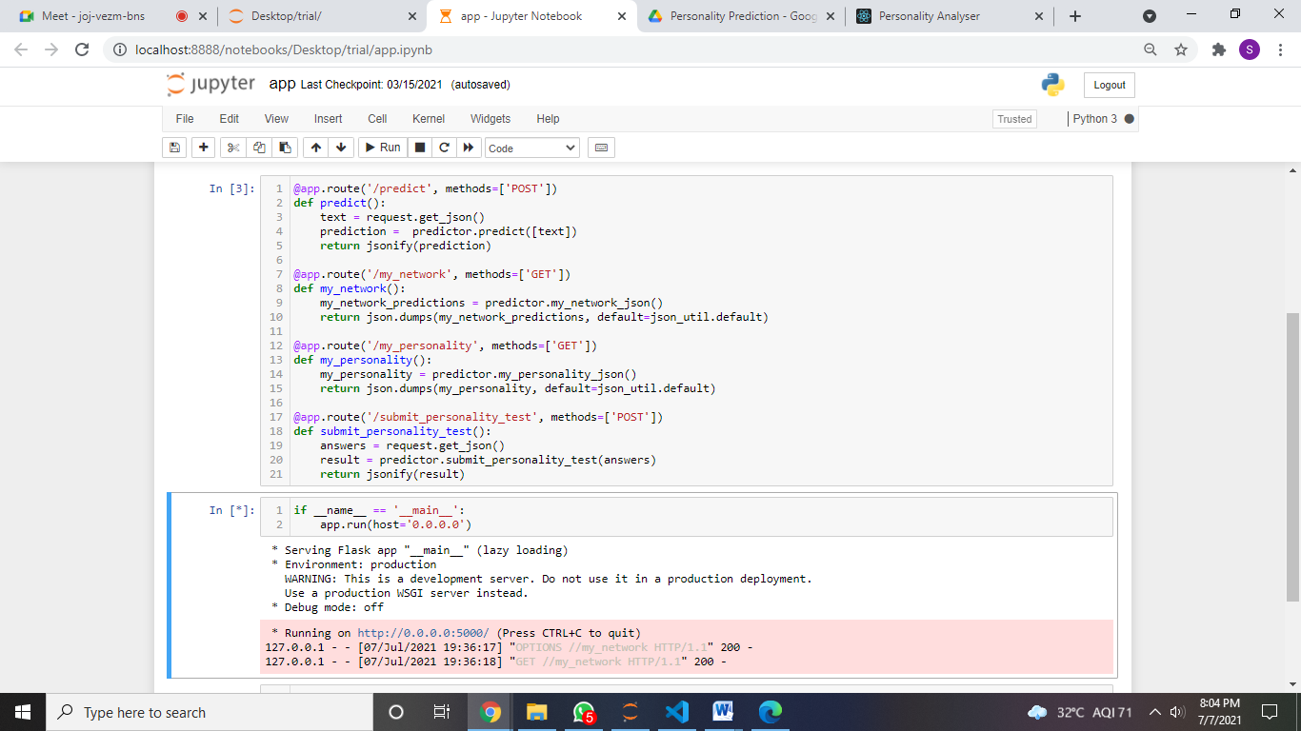

1. Check if the information in available at **localhost:5000/my_network.**

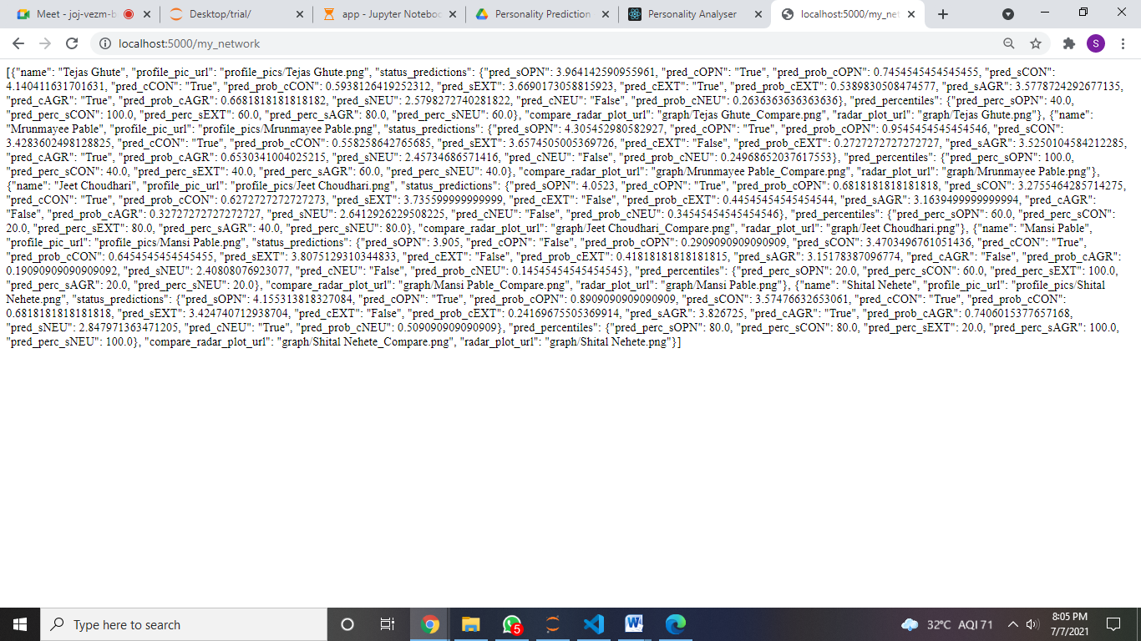

1. Change the path to Desktop and run command, **npx create-react-app trial**, on command prompt.

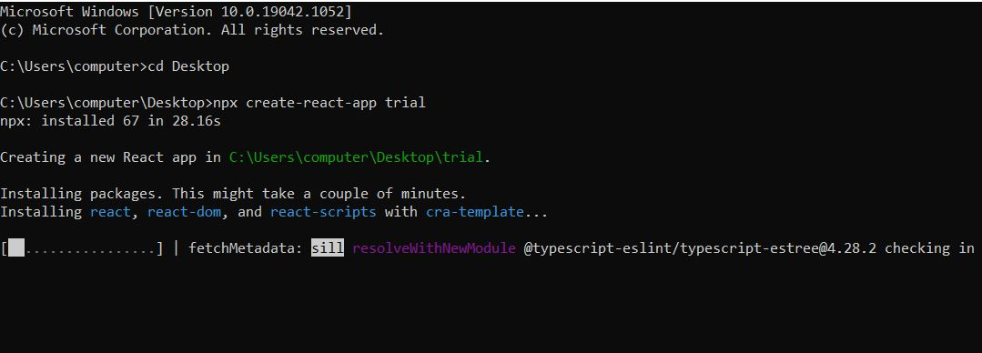

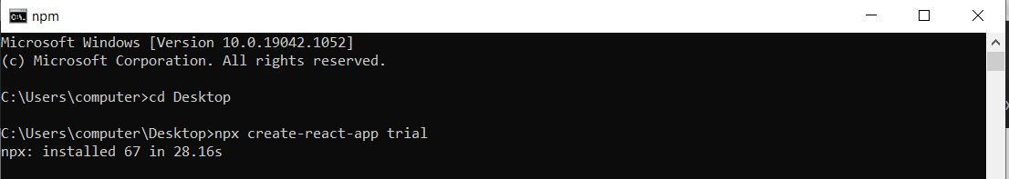

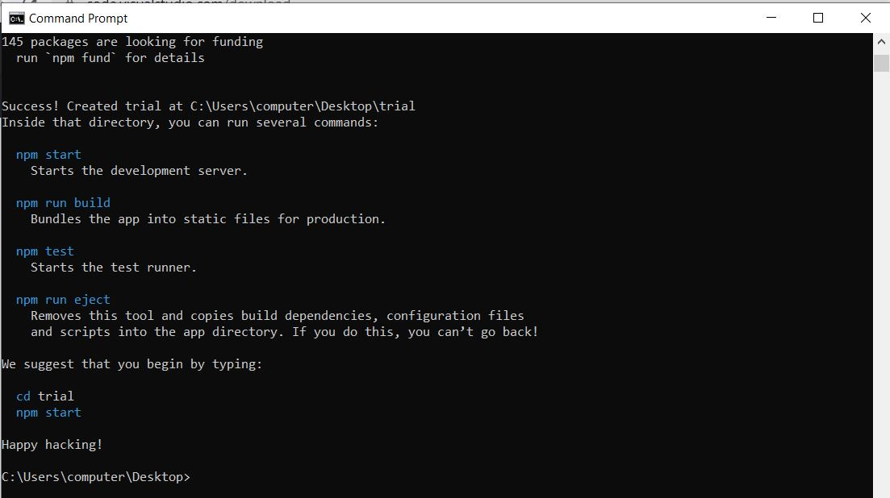

1. The folder name **trial** will be created on Desktop. Copy the src folder into the latest created src folder.

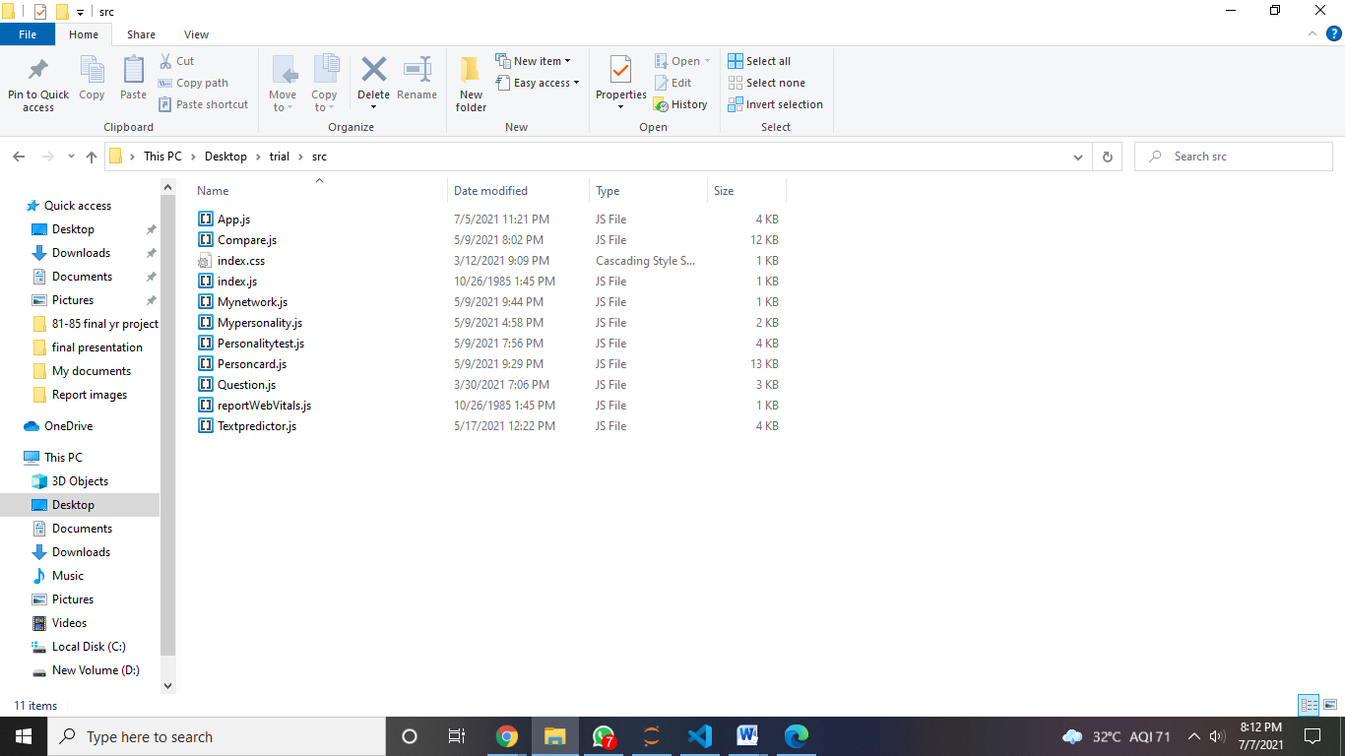

1. Now after copying, do **cd trial** and run the command, **npm start**, on command prompt.

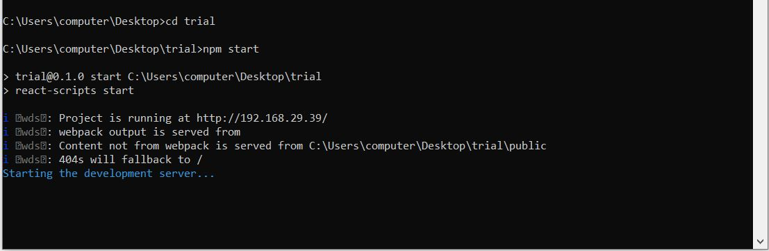

1. Now, the front-end will be visible on **localhost:3000.**

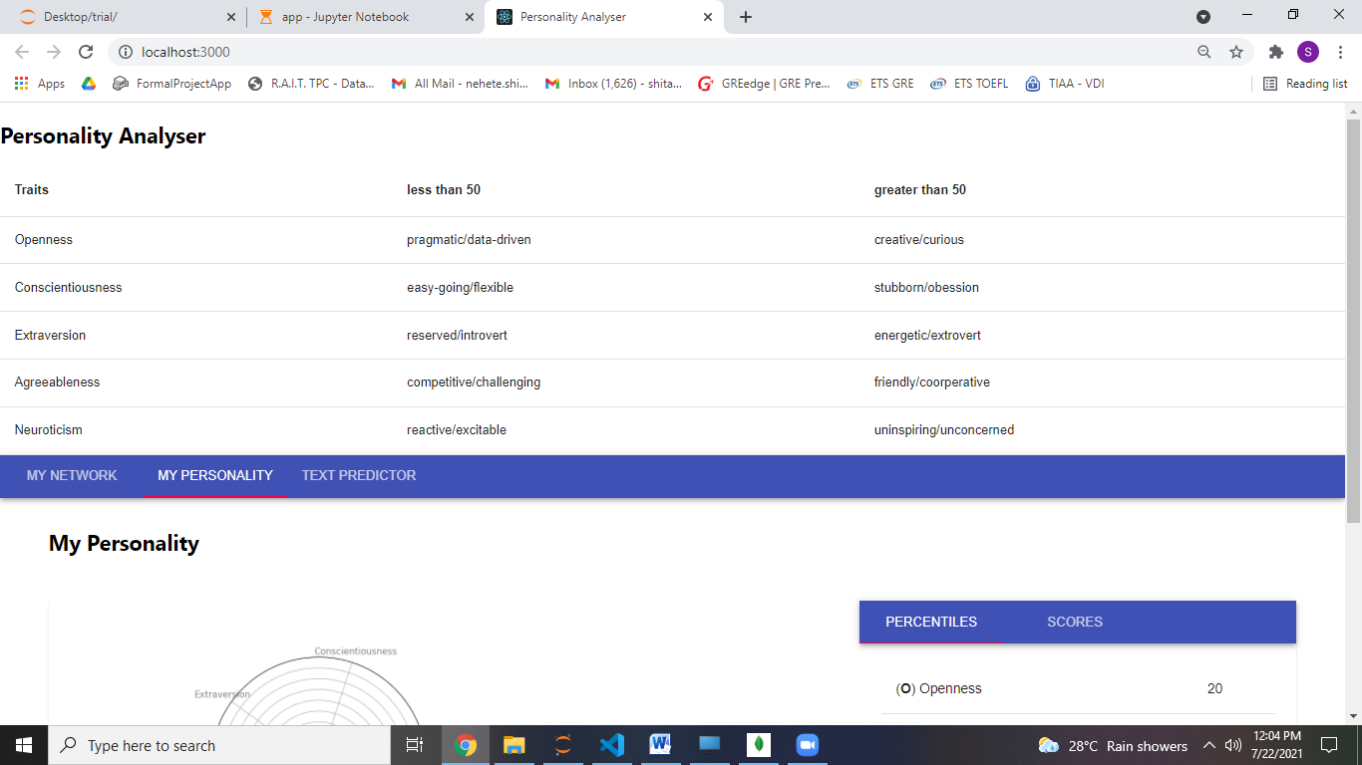

1. Click on **Text Predictor** tab for predicting the **OCEAN** traits based on the textual data.

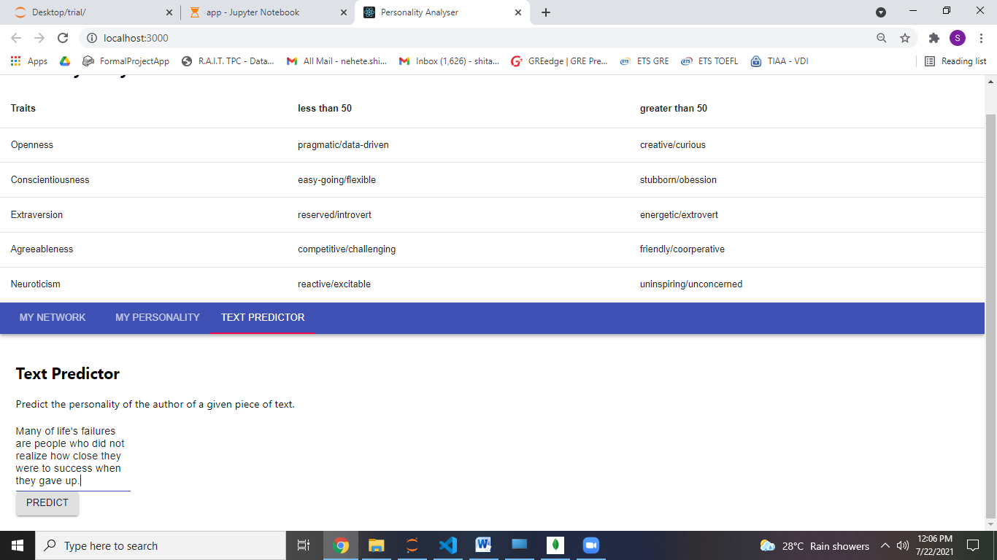

1. Click on the **Predict** button below for displaying the traits scores, probabilities and category.

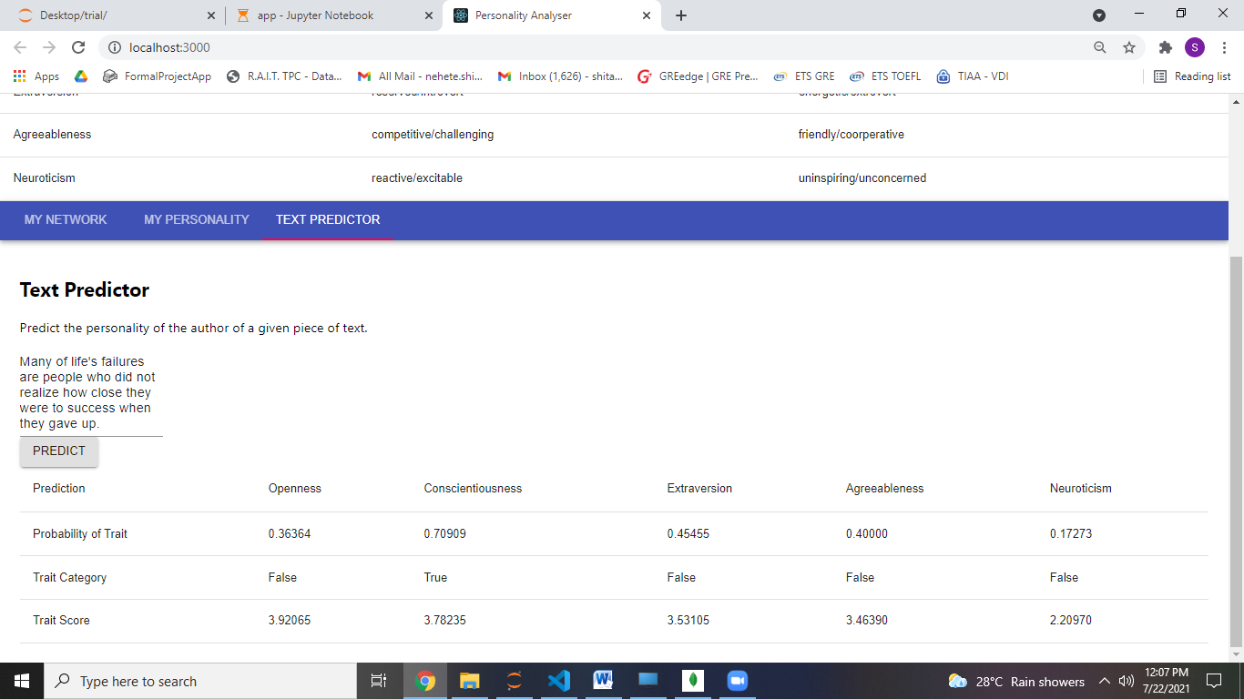

Few more examples on Text Predictor

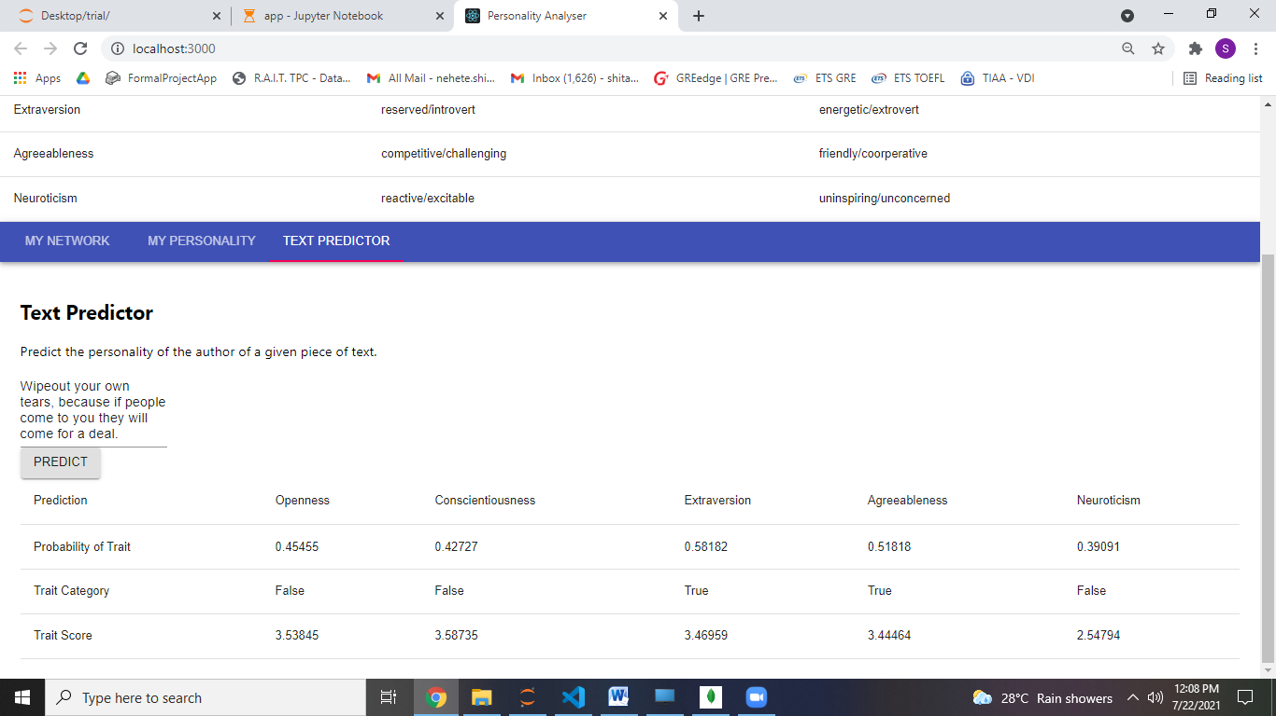

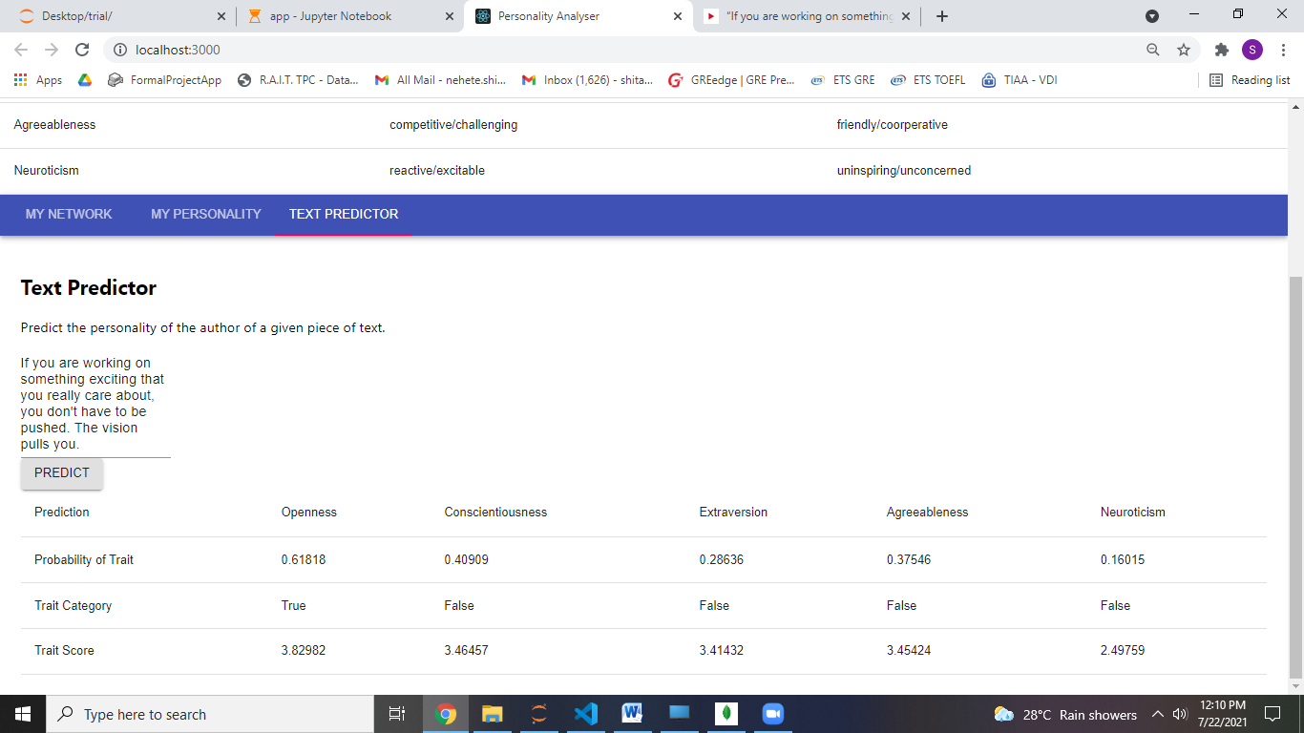

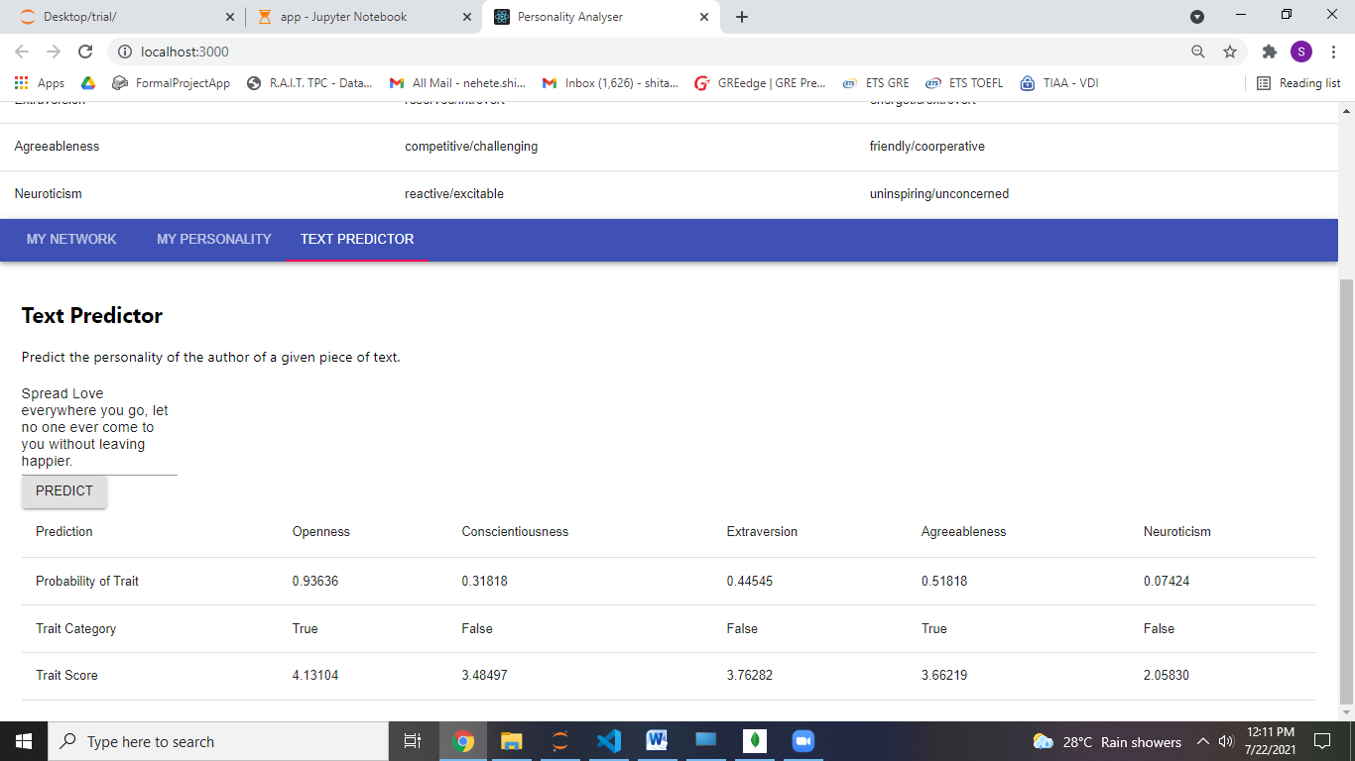

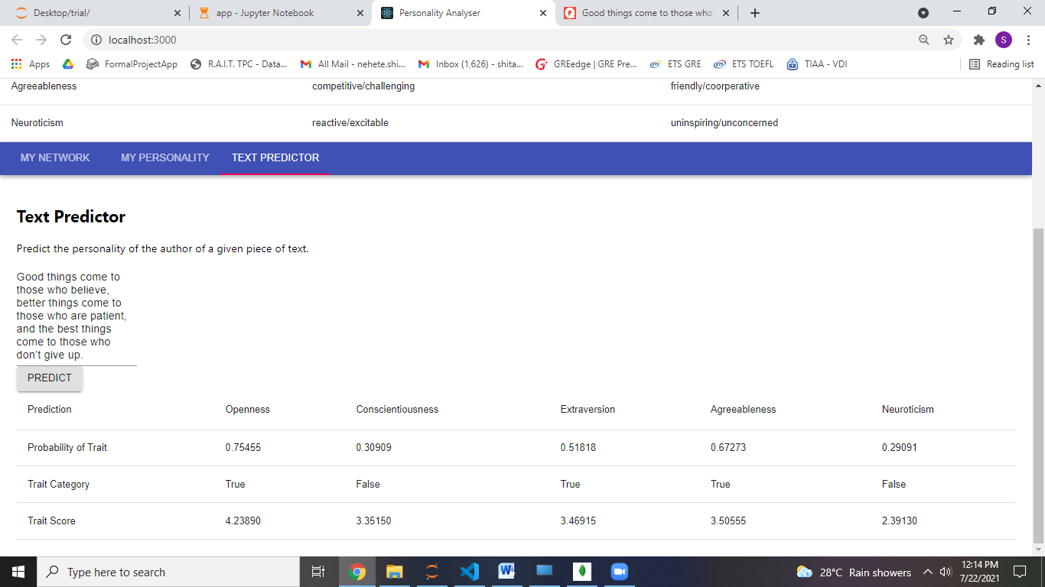

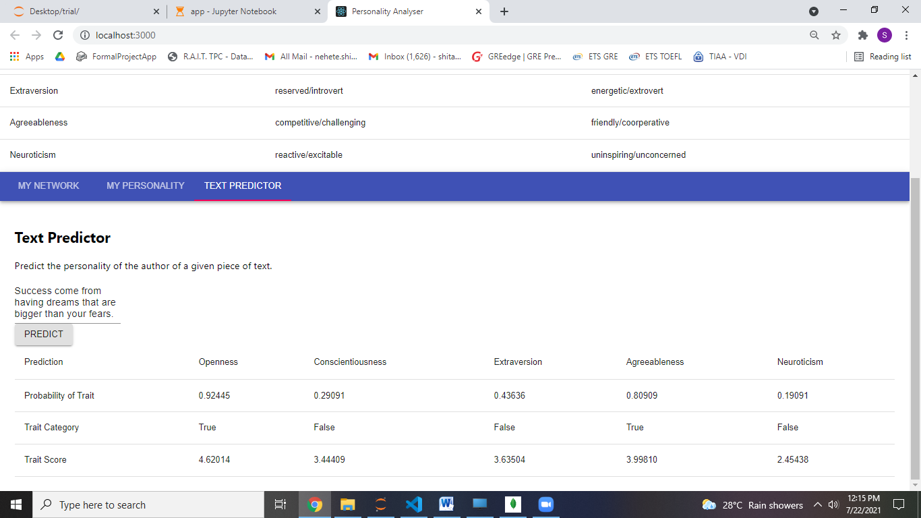

1. For predictingOCEAN traits scores based on Questionnaire click on **My Personality** tab.

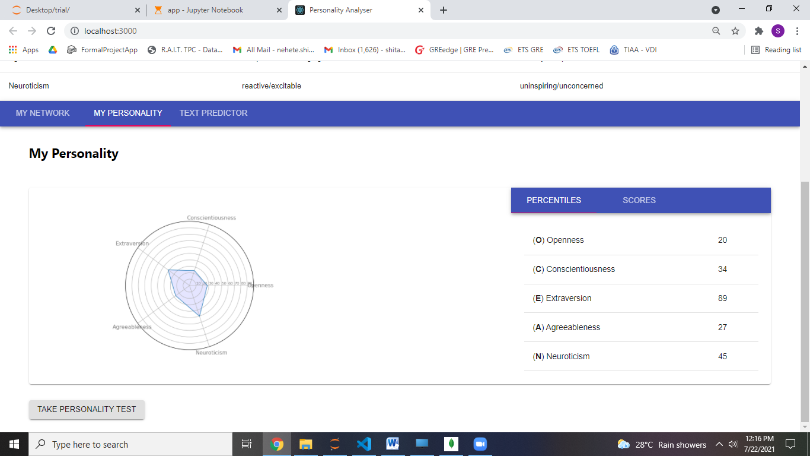

1. Now click on **Take Personality test** for taking the Questionnaire and answer the situation by sliding the pointer from 0 to 5 (Strongly Disagree, Disagree, Neutral, Agree, Strongly Agree).

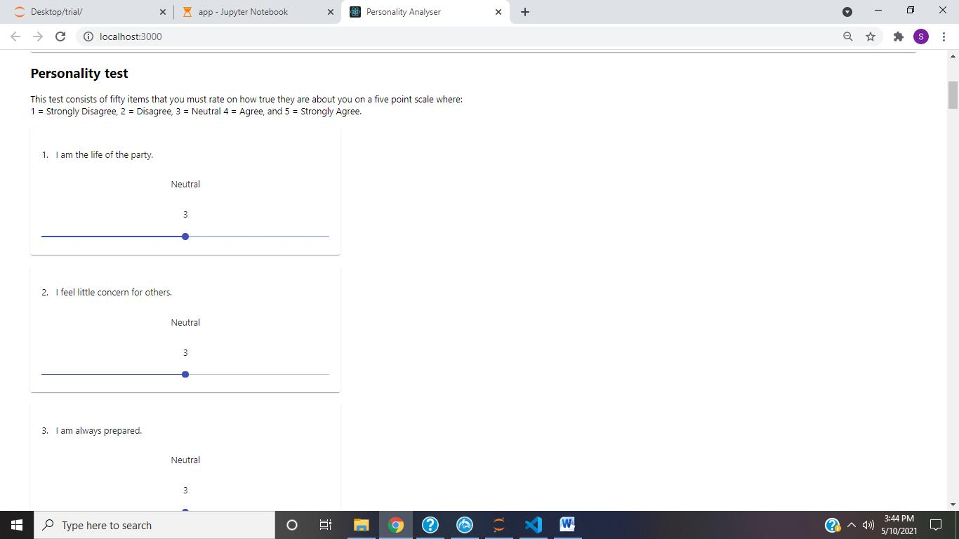

1. After answering all 50 questions click on **Submit** button for calculating the traits score and percentiles and wait till the page **reload**.

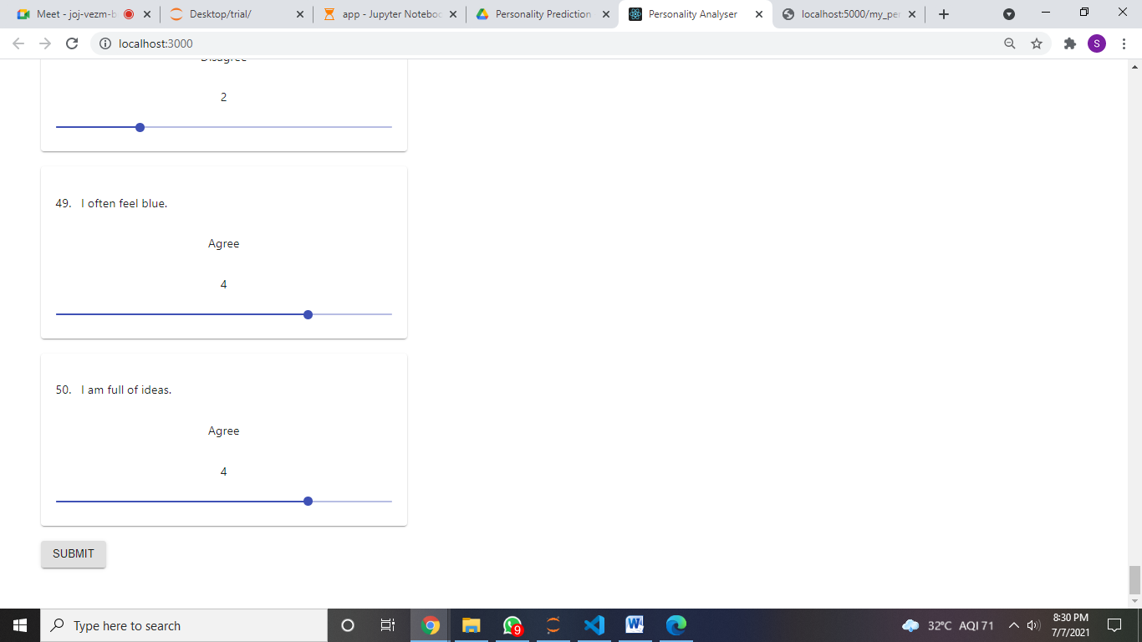

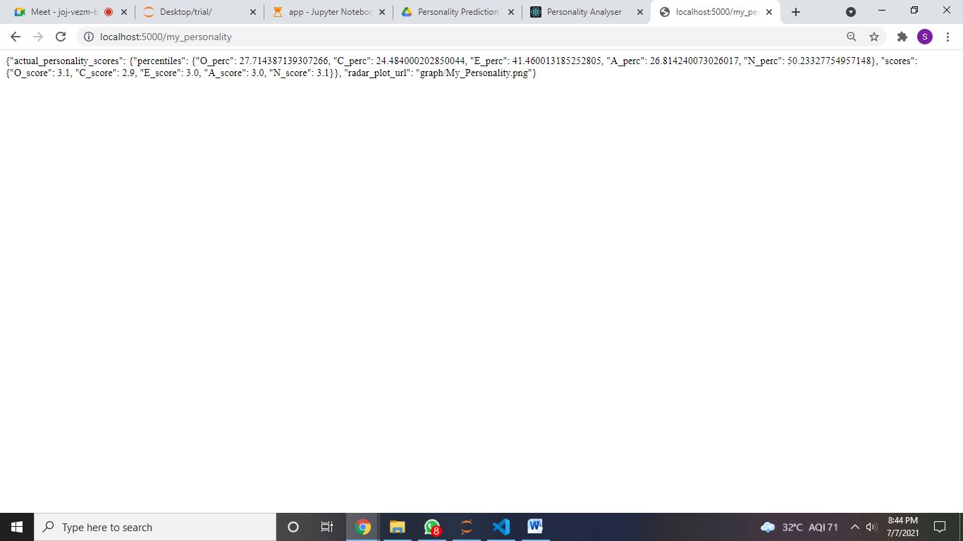

1. For comparing the personality when the **Facebook** Friends’ click on **My Network** tab. It will show the Percentiles, Probabilities and Scores of the OCEAN traits for the 5 friends.

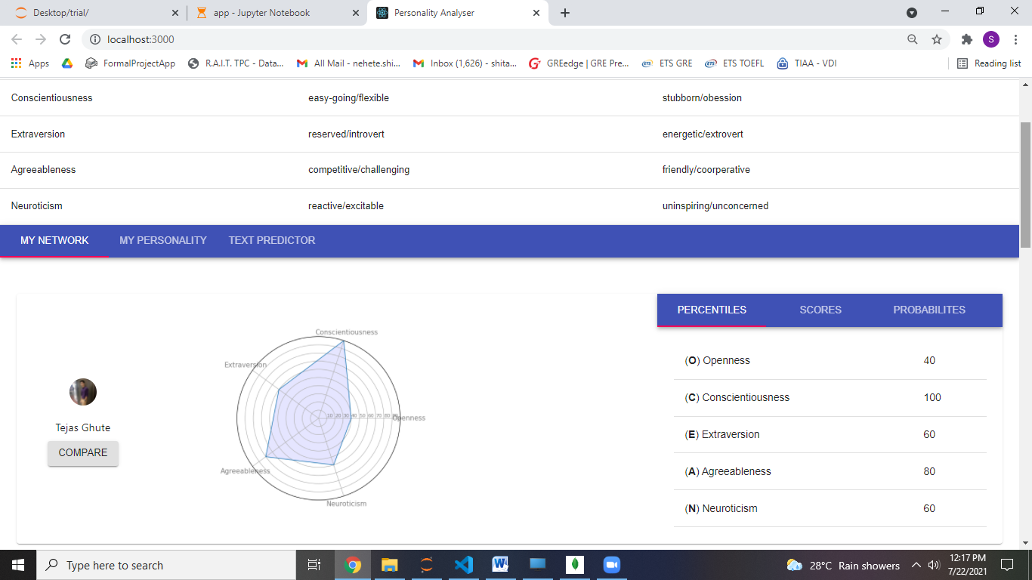

1. For comparing with your personality click on the **Compare** button. The comparison will be shown in difference as well as the in Radar Graph.

